First Announcement
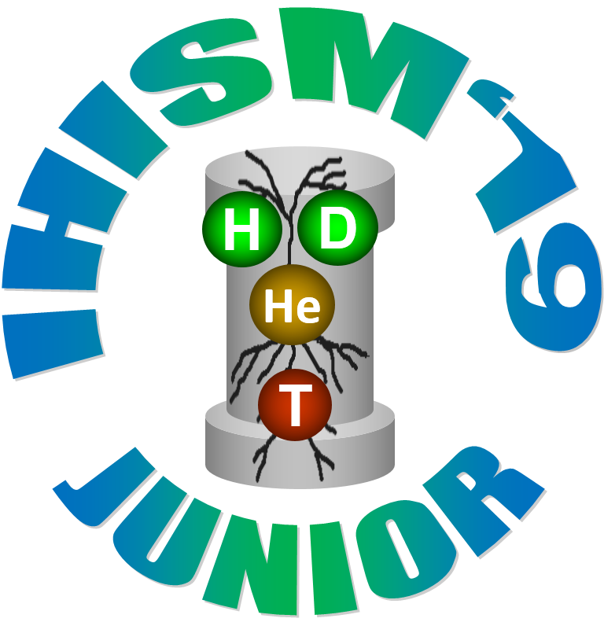

INTERACTION OF HYDROGEN ISOTOPES WITH STRUCTURAL MATERIALS

The 3rd International School-Conference of Young Scientists and Specialists Named after A.A. Kurdyumov

01 - 05 July, 2019
Sarov
Organizers:
The State Corporation “Rosatom”
FSUE “RFNC-VNIIEF”
RRC “Kurchatov Institute”
RFBR

DEAR COLLEAGUES!
The Organizing Committee invites students, postgraduate students and young researchers, scientists and engineers, employees of industrial companies at the age of up to 35 and tutors of higher education institutes to take part in the School-Conference dedicated to the problem “Interaction of Hydrogen Isotopes with Structural Materials”.
Topics of the School-Conference
Section №1: «Kinetics of hydrogen isotopes interaction with solids, including the effects of radiogenic helium».
Section №2: «The influence of hydrogen isotopes on the properties of structural materials».
Section №3: «Hydrides and hydride transformations».
Section №4: «Models, methods and equipment».
Data and Place
The School-Conference will be held 01 – 05 July, 2019 in the city of Sarov in the FSUE “The Russian Federal Nuclear Center – All-Russian Research Institute of Experimental Physics” (http://vniief.ru/).
Conduct Procedure
The work of the School-Conference will be organized by topical sessions. The sessions will be held in the form of invited lectures of the leading Russian and foreign specialists followed by free discussions and presentations by the “School students” with the description of their own results with respect to the topics under consideration. The duration of the lectures will be up to 50 minutes and the duration of the student presentations will be up to 15 minutes.
The abstracts of the presentations and overview lectures will be published in the proceedings of the School-Conference. In order to publish the abstracts, an official permission for the publication is required from respective organizations.

Registration
The registration of the participants is up to 15 February, 2019 in the electronic form at the official site of the Conference: http://ihism.org.
The official invitations will be sent by the Organizing Committee not later than on 01 April, 2019.
The questions connected with the payment for the participation in the work of the School and accommodations will be provided in the second information message.

Contacts
607188, 37, Mira Ave., Sarov,
Nizhniy Novgorod Region, Russia.
FSUE “RFNC-VNIIEF”.

Yukhimchuk Arkadiy Arkadievich
Phone: +7 (83130) 23473
Fax: +7 (83130) 25735
e-mail: arkad@triton.vniief.ru

Maksimkin Igor Petrovich
Phone: +7 (83130) 25610
Web site:
http://ihism.org.
e-mail: info@ihism.org

The International Program Committee
Co-Chairs:
Ilkaev R.I., RFNC-VNIIEF
Kovalchuk M.V., RRC “Kurchatov Institute”
Co-Chair Deputies:
Yukhimchuk .А.A., FSUE “RFNC-VNIIEF”
Romannikov А.N., RRC “Kurchatov Institute”

Members of the Committee:
Verbetzkiy V.N., MGU named after M.V. Lomonosov
Denisov E.A., SPbGU
Ilgisonis V.I., The SC “Rosatom”
Zaika Yu.V., KarNC RAS
Kalin B.A., NIYaU “MIPhI”
Livshits A.I.,SPbGUT
Magomedbekov E.P., RKhTU named after D.I. Mendeleev
Postnikov A.Yu., FSUE “RFNC-VNIIEF”
Netskina O.V., I.K named after G.K. Boreskov SO RAS
Morozov O.M. (KhFTU, Ukraine)
Tazhibaeva I.L., IAE NYaTz RK, Kazakhstan
Semyonov A.A.. AO “VNIINM”
Khapov A.S., VNIIA named after N.L. Dukho)
M. Mayer, IPP, Jermany
Y. Hatano, U. Toyama, Japan

Secretary
Golubeva A.V. (RRC “Kurchatov Institute”)

The Executive Committee
Chair:
Maksimkin I.P., RFNC-VNIIEF

Chair Deputy:
Spitsyn A.V., RRC “Kurchatov Institute”

Members:
Ananyev S.S., RRC “Kurchatov Institute”
Buchirin A.V. RFNC-VNIIEF
Vertey A.V., RFNC-VNIIEF
Zhmurovskiy A.V., RFNC-VNIIEF
Krymov P.Yu., RFNC-VNIIEF
Ryzhukhina A.V., RFNC-VNIIEF
Senyaguina M.N., RFNC-VNIIEF
Tivikova О.А, RFNC-VNIIEF
Tikhonov V.V., RFNC-VNIIEF
Shevnin E.V., RFNC-VNIIEF

Secretary:
Tsaryova I.A., RFNC-VNIIEF (РФЯЦ-ВНИИЭФ)

Key Dates
School-Conference 01.07 - 05.07.2019
Registration deadline 15.02.2019
Abstract submission deadline 15.03.2019
Invitation 01.04.2019

The Organizers of the School-Conference

 | 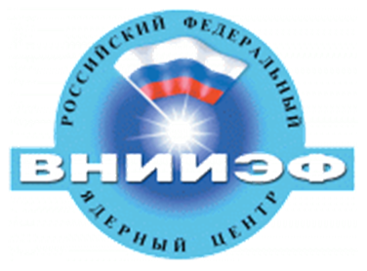
 | 

